## Privacy Notice for Children

We are here to look after you.

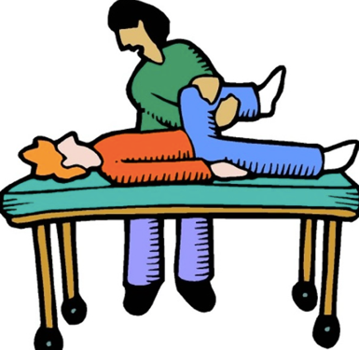

And to do this, we need some information to assess your medical needs fully and treat you well



This information will be kept safe and securely.

The law states we have to keep your information safe and sound for no less than 25 years but you can access them at any time, you can ask for us to change them if you disagree with what we say and after 25 years, you can ask us to have it erased.

All you need is to call us and let us know, we are always happy to help.

Tel: 01823 256440